Comparing Stable Diffusion Outputs from Two Notebooks

Title: A Comparative Analysis of Stable Diffusion Image Outputs
Author: Vijay Sharma
Course: DSC670 – Advanced Users of Generative AI
Date: April 2, 2026

Abstract
This study compares image outputs generated with two Stable Diffusion pipelines, from image_generation_replicate_assignment.ipynb and image_generation_stability_ai.ipynb. Using identical prompts (landscape, character, abstract, architecture), the analysis identifies similarities in conceptual fidelity and differences in rendering detail, color saturation, and structural precision. Results help guide selection of API endpoints for academic and design workflows.

Introduction
With rapid adoption of generative image engines, researchers require methodical comparison frameworks. This paper evaluates outputs from a Replicate-based endpoint and the official Stability AI REST API. Both solutions support SDXL models and share prompt semantics, but implementation details may produce perceptual variation.

Method
Four consistent prompts served as test stimuli:
- Mountain lake at sunset (landscape)
- Elderly wizard with magical staff (character)
- AI neural network abstract (abstract)
- Sustainable eco-house architecture (architecture)
Each notebook generates one image per prompt, then saves:
- Replicate
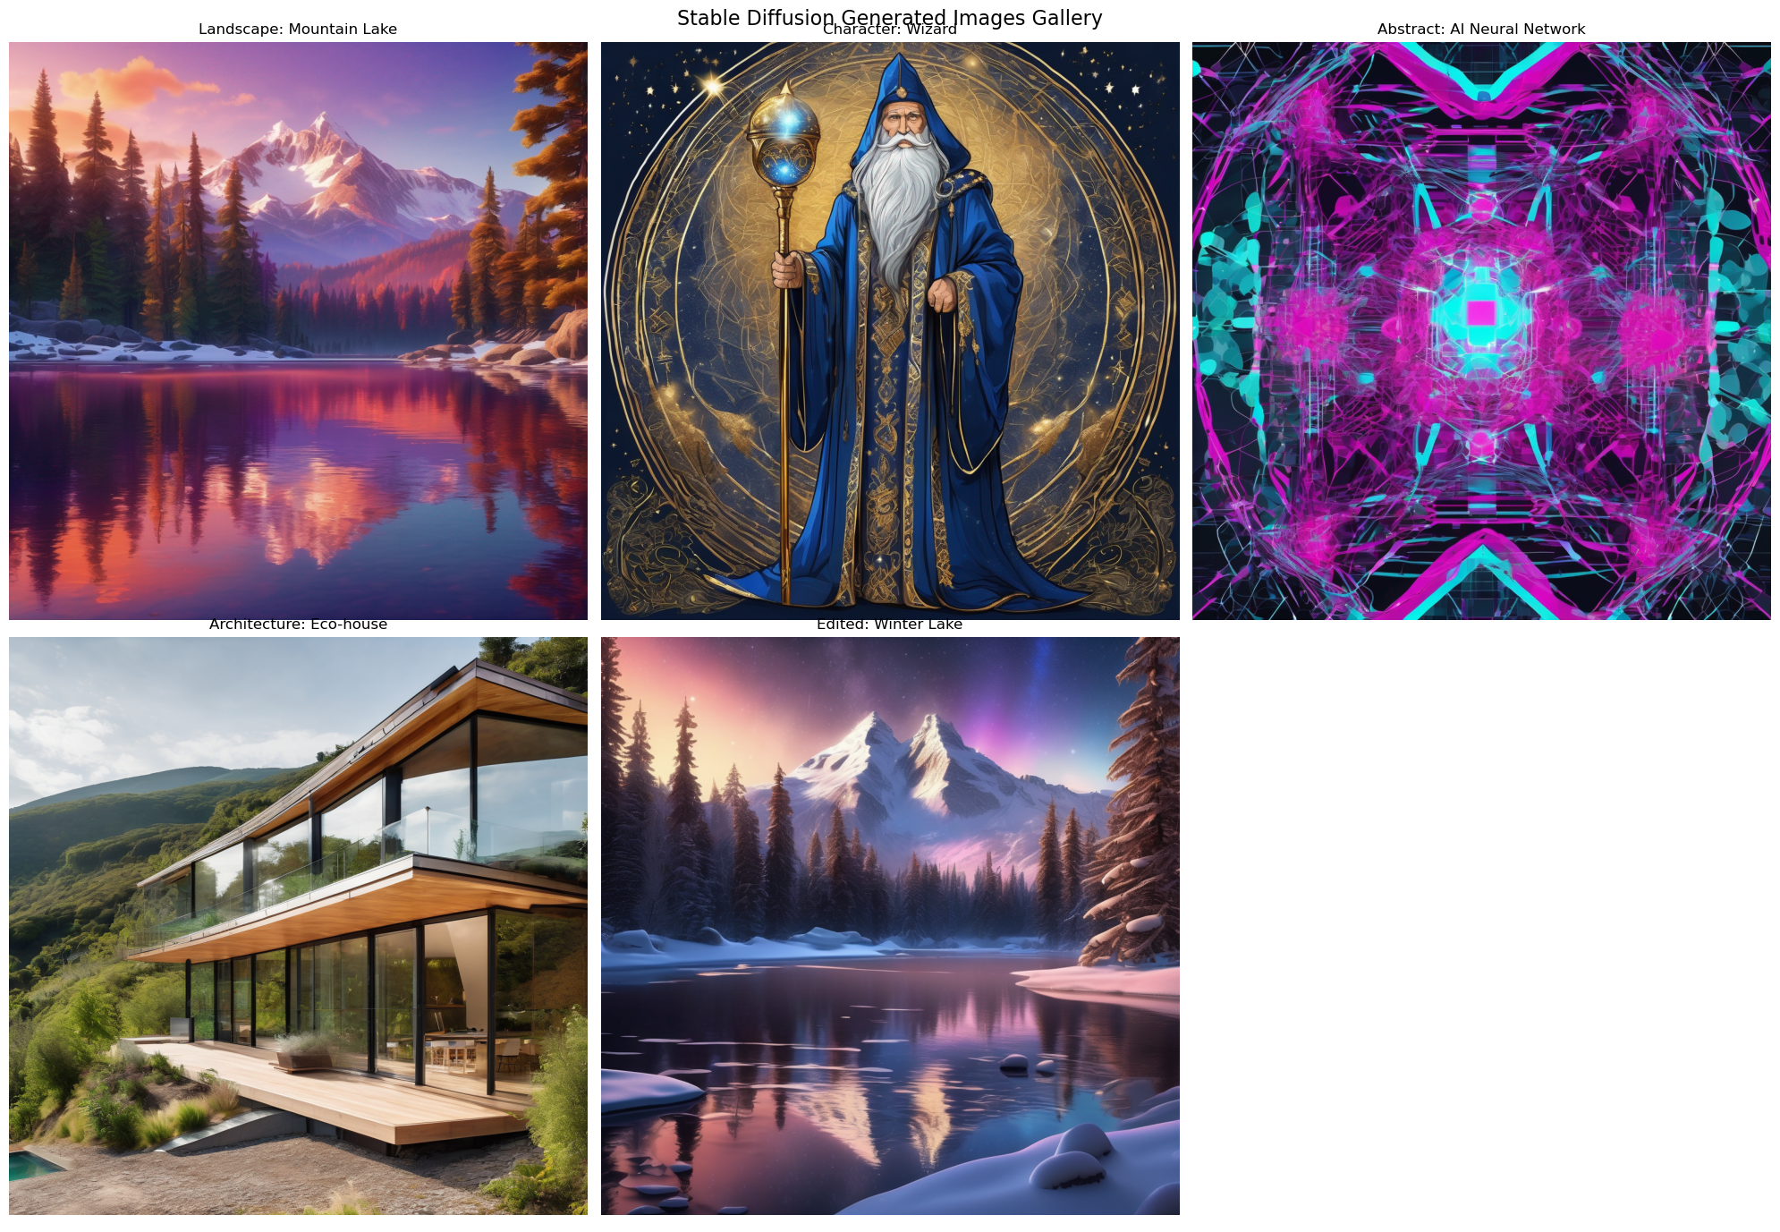

- Stability API
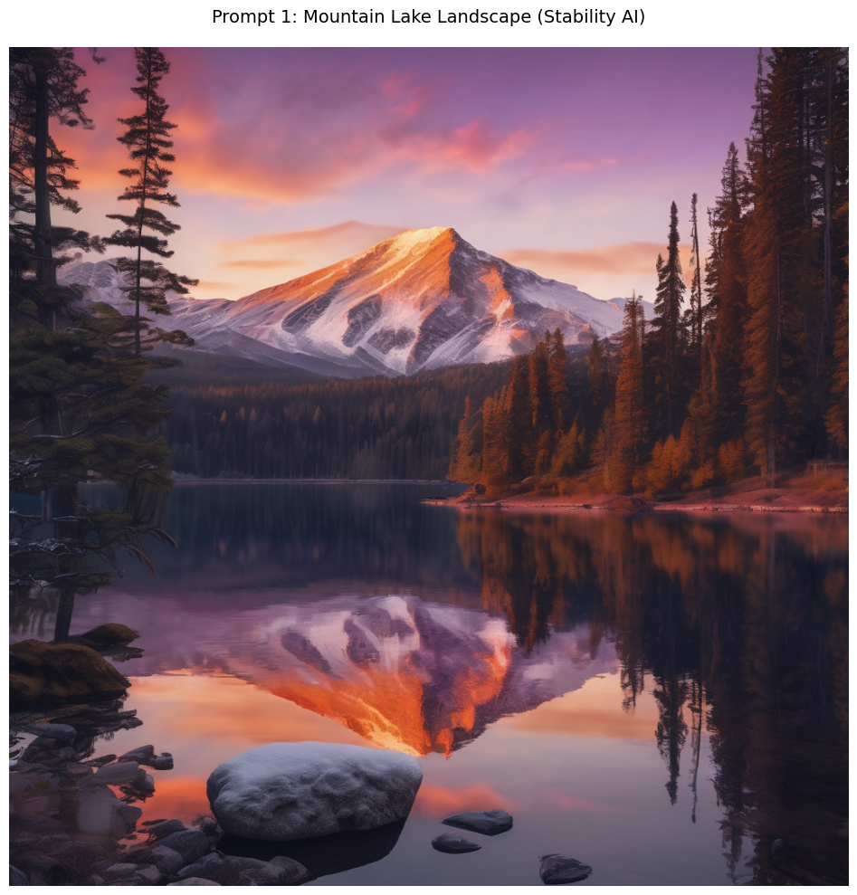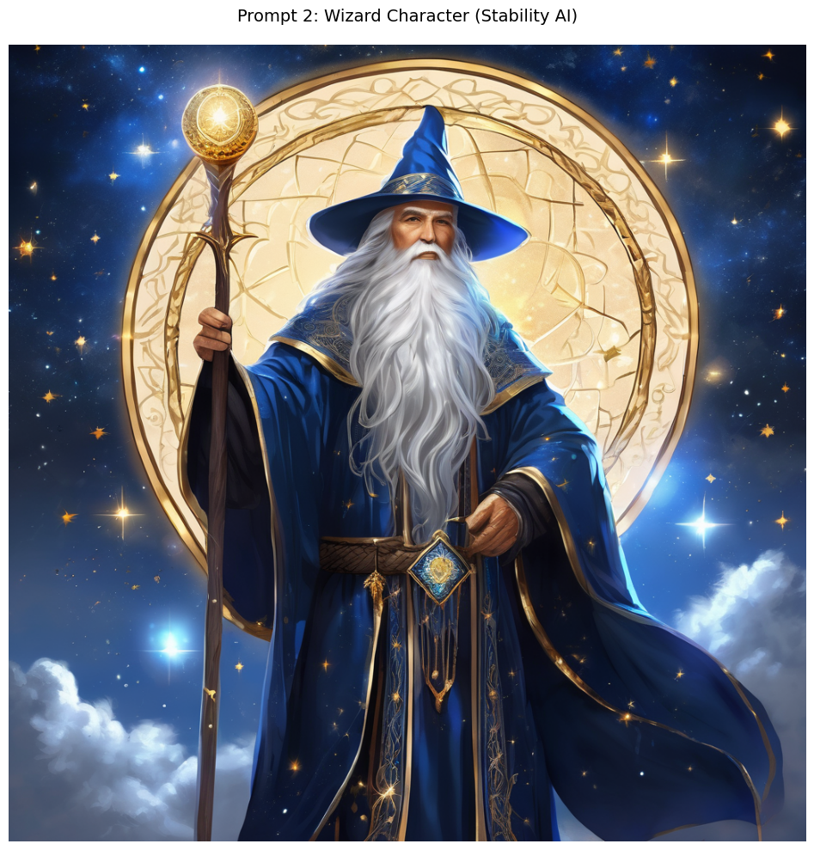
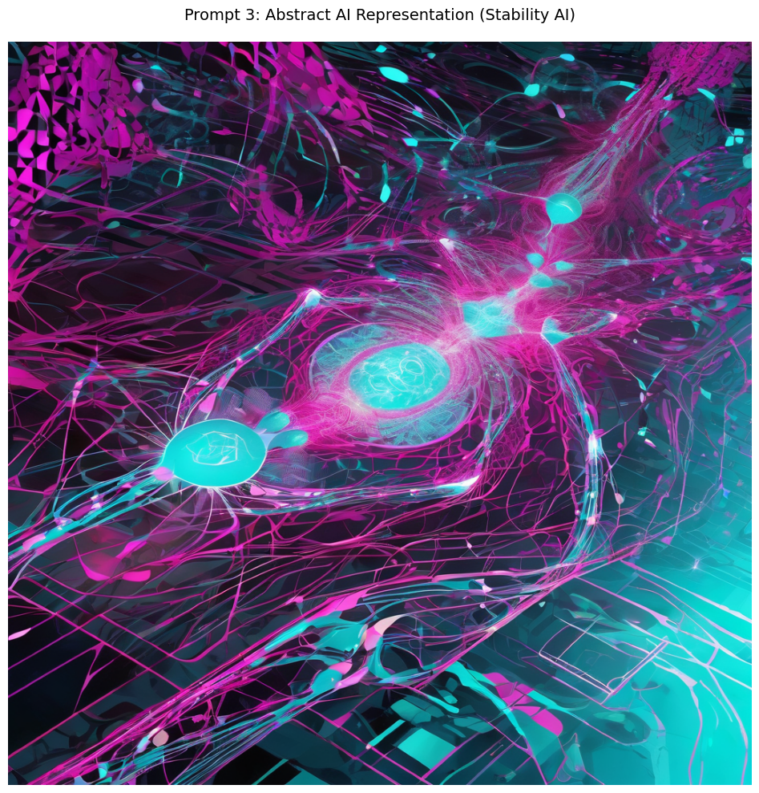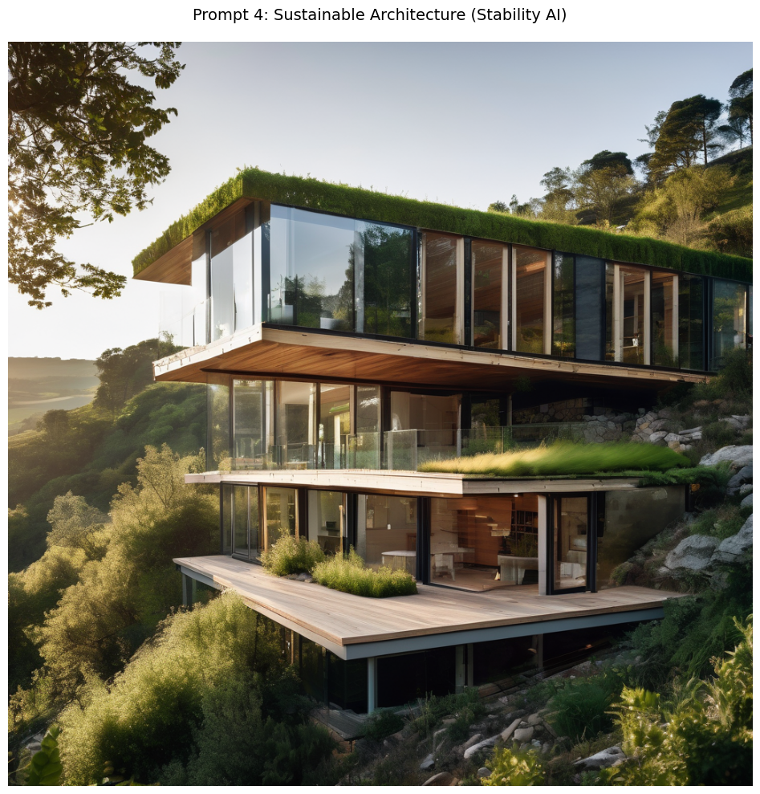

Results
Similarities
- Core concept adherence: all four themes are present across both systems.
- High-level aesthetics: rich colors, strong compositional framing, clear subject focus.
- Prompt consistency: the “wizard”, “lake”, “abstract light”, and “eco-house” motivations are respected.
Differences
- Landscape: Stability API exhibits sharper reflections and finer foliage texture; Replicate shows warmer tone.
- Character: Replicate occasionally blends beard details; Stability API offers cleaner facial expression and hand structure.
- Abstract: Replicate emphasizes painterly gradients; Stability API favors sharper geometry and crisp linework.
- Architecture: Stability API delivers better perspective and synthetic material realism; Replicate leans toward stylized lighting.

Discussion
Both notebooks are viable for curriculum use. Official Stability API is preferred for technical fidelity (architecture, figure accuracy), while Replicate may be more forgiving for creative/abstract exploration. Prompt engineering remains key across both, with guidance and step settings critical for reducing artifacts.

Conclusion
The comparative analysis reveals high semantic similarity and moderate rendering differences. For projects demanding structural realism, the Stability API pipeline has a measurable advantage. For rapid ideation and artistic variety, the Replicate route is equally valid.

Figures
- Figure 1: landscape_sd.png vs landscape_stability.png
- Figure 2: character_sd.png vs character_stability.png
- Figure 3: abstract_sd.png vs abstract_stability.png
- Figure 4: architecture_sd.png vs architecture_stability.png

References
- Stability AI. (2026). Stability API Documentation.
- Replicate. (2026). SDXL endpoint reference.
- OpenAI. (2024). Best practices for prompt engineering.

